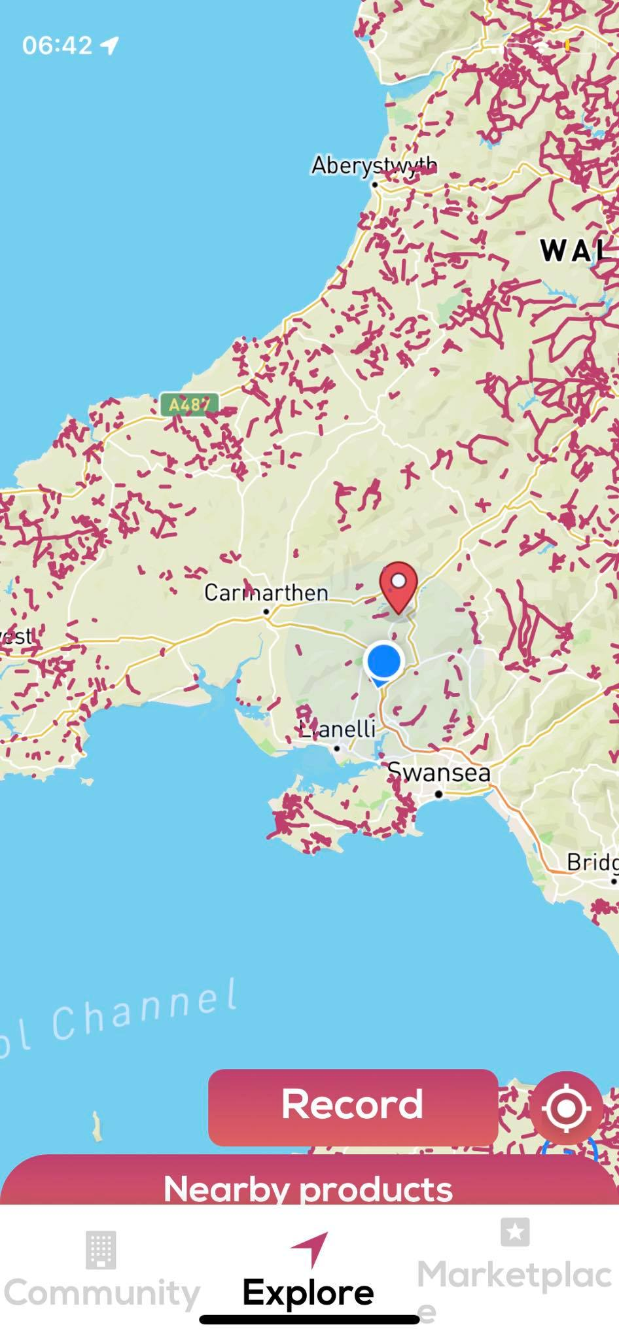

Bridleways.aoo showing the Carmarthenshire area is devoid of any sort of bridleway network. Our routes were incorrectly classified as footpaths with the intention of revisiting the issue at a later date.

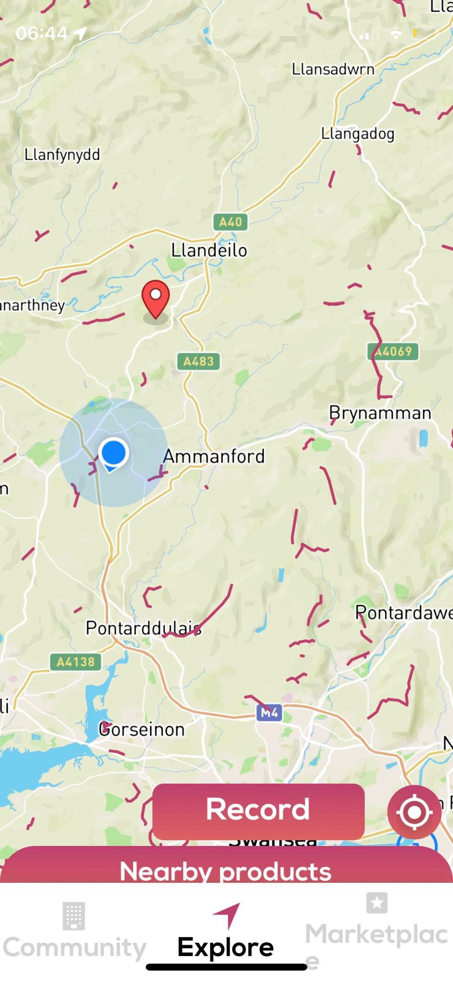

Bridleways.app showing the lack bridleways in the area and the need for safe off road access for horse riders. The Active Travel Act clearly states in section ?? that equestrians can be included in Active Travel schemes if there is demand.

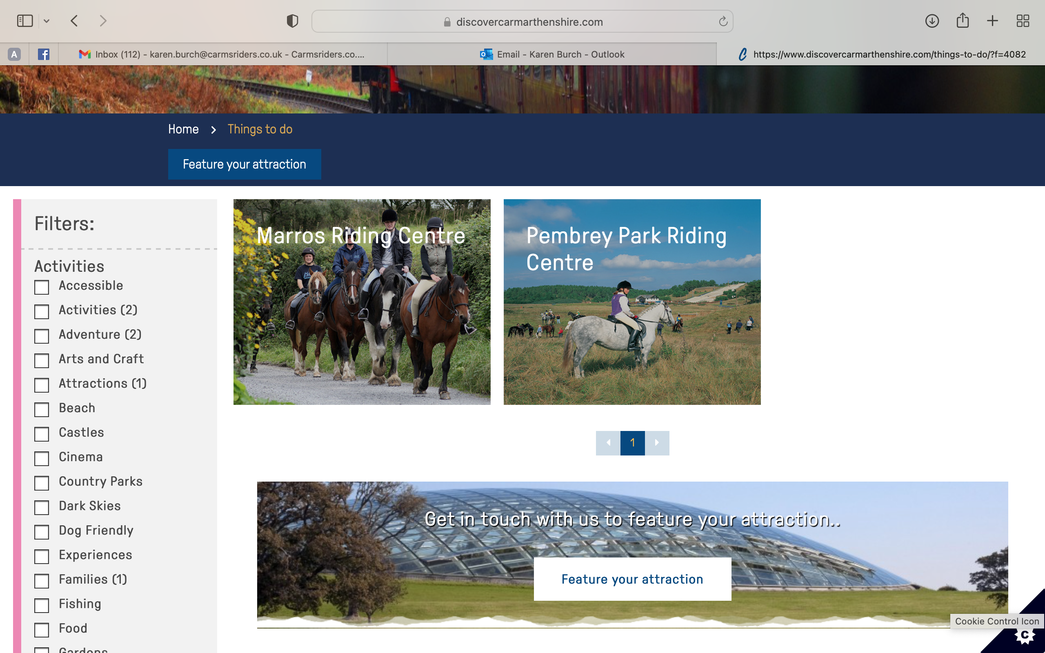

Discover Carmarthenshire website. Only 2 entries for horse riding or carriage driving and both are commercial premises not access to the countryside for the public with their own horse. There are 22,000 passported horses in Carmarthenshire using 6% of the rights of way network. By law horses need a passport after the age of 6 months of age. There are 81 members of the Cross Hands Riders facebook group, set up to lobby the community council for safer on and off road access.

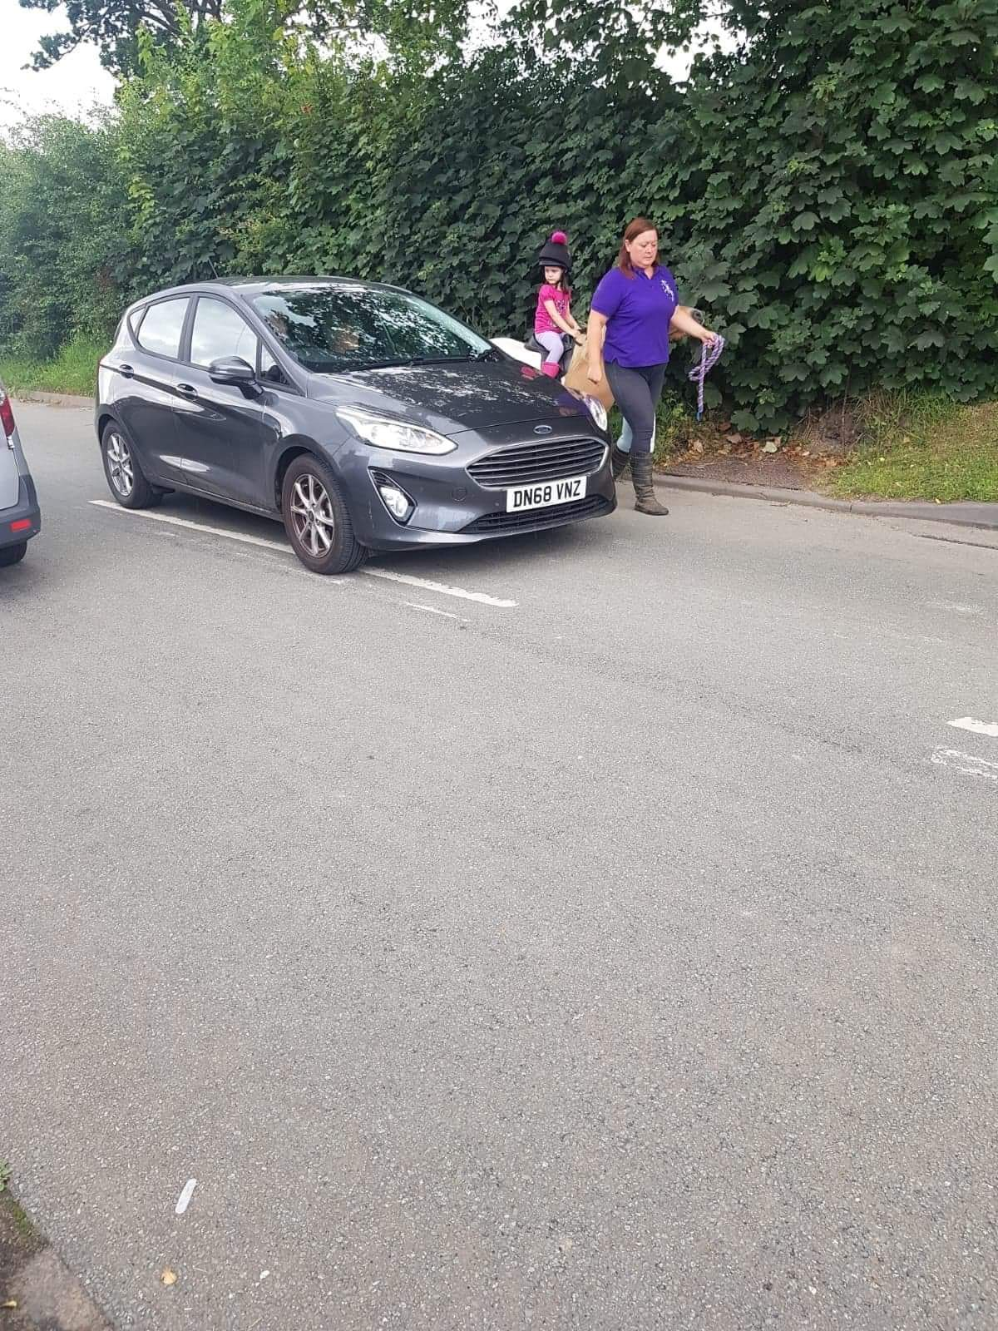

This is the reality of our problem. We cannot travel to Pony Club, the vets, meet friends or access quiet lanes in the area any more. We cannot ride to LLyn Lech Owain because of the increased traffic and the County Council have banned us from the carpark. We need an alternative parking area and other green space to ride, as well as access to all off road paths created for walking and cycling.

