Representation No. 5295 – Objection to the non-inclusion of site AS2/012/001

Sustainability Appraisal of proposed extension linked to Representation No. 5295
Following discussions on the evolution of site reference CA0053 (land adjacent Darren View
SC42/h1) the 2nd deposit of the LDP has included a revised area of land adjacent to the Old
Tailors (map reference 51.952138 , -4.144805) (Image 1). This land belongs to land that was included as a candidate site in the previous LDP (Image 2)
Image 1. Proposed development limits in Second deposits rLDP
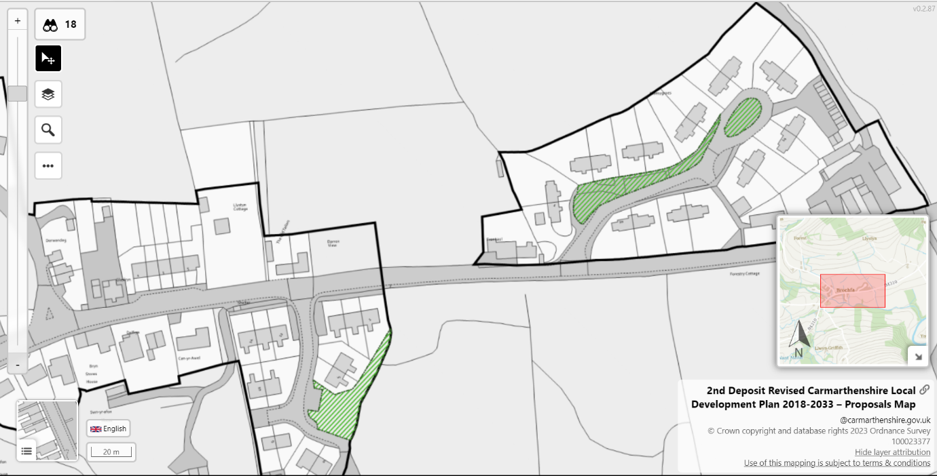
Image 2. Candidate site in previous LDP
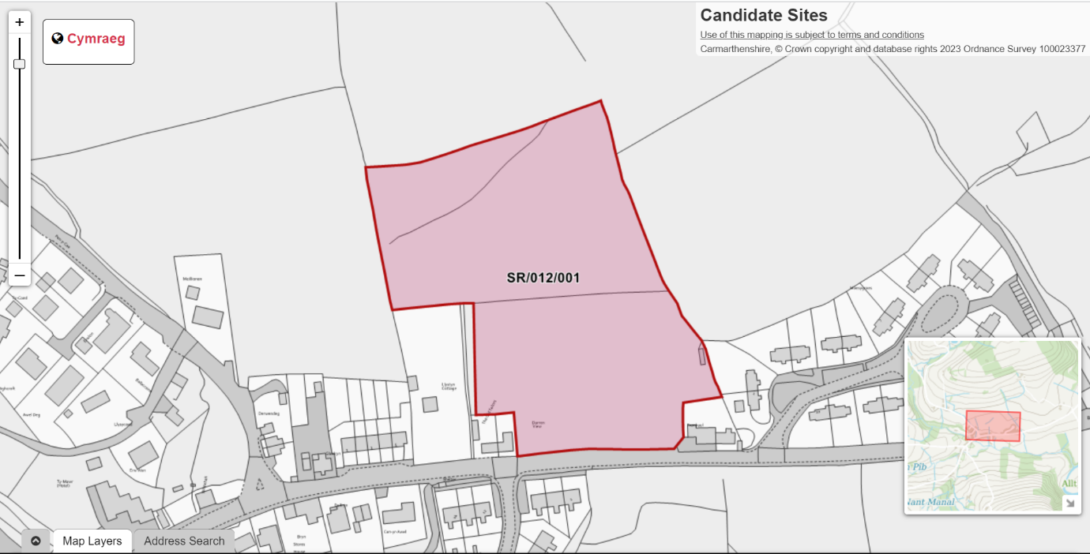
Following discussions on the evolution of site reference CA0053 (land adjacent Darren View
SC42/h1) the 2nd deposit of the LDP has included a revised area of land adjacent to the Old
Tailors (map reference 51.952138 , -4.144805).
This was revised following discussions on plans to develop only the land adjacent to
Abergorlech Road (B4310) of the original CA0053 site.
As land owner, I would appreciate a reconsideration of the allocated area and redefined
development limits. To unite the disparate upper and lower areas of the village into one
cohesive whole, the development limits to be extended from the current allocation to Fronhaul to
the East of the current limit. (See image 3)
As has been discussed with the forward planning officer, there is a current pre-planning
application submitted for the land discussed above, with a full planning submission to follow
once comments on the proposed development have been received.
Image 3. Proposed extension to development limits
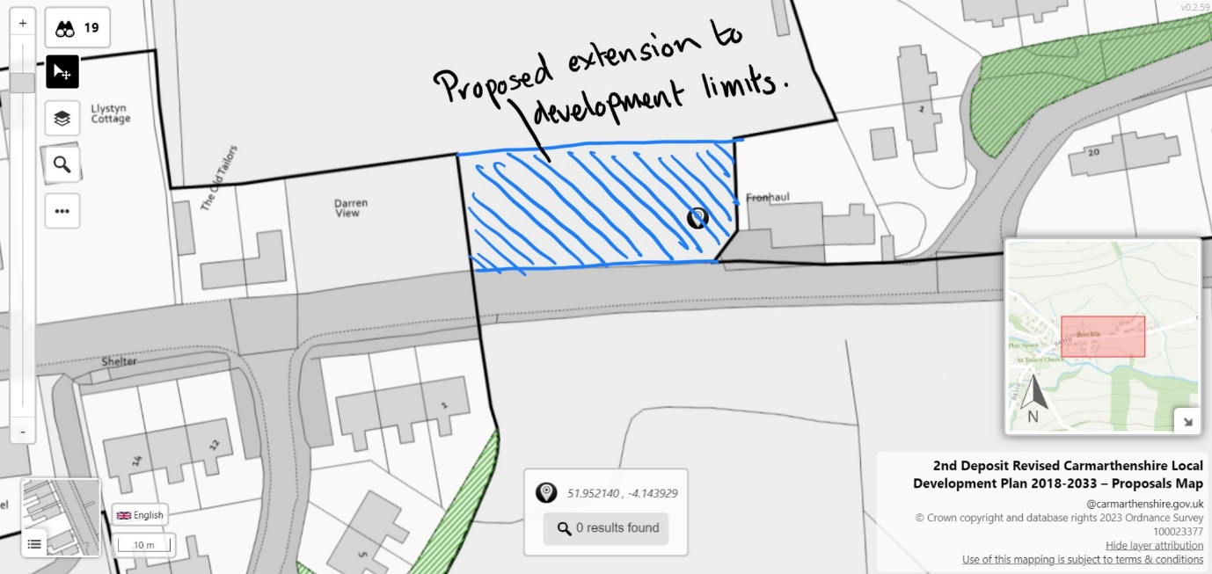

Sustainability appraisal

Question | ISA Objective(s) | Comments
Q1. Is the site compatible against the location of future growth presented in the Deposit LDP? |  | The site supports the key statements presented within the deposit LDP. The site will allow for proportional development within a rural community that can make a positive contribution towards the long-term sustainability and cohesiveness of the rural community and economy of Brechfa within the Upper Tywi geographical area.
Q2. Can the site accommodate 5 or more dwellings? |  | Yes
Q3. Is the site within, or directly related to an identified settlement in Tiers 1-3 of the LDP Preferred Strategy? |  | Yes. Site sits within Tier 3 sustainable villages. The proposed extension of development limits, that was part of previous LDP, the site joins the boundaries of existing development limits within the village of Brechfa, uniting the East and West aspects of the village. See appendix 1.
Q4. Is the site located within a flood risk zone? |  | Site is located within Zone A of the Development advice maps and is not located within any layer contained within the flood map for planning. See appendix 2.
Q5. Is the site located within or immediately adjacent to any sites designated for importance to nature conservation? | ISA2 | Yes. The application site is within the catchment of the Afon Tywi Special Area of Conservation (SAC). It is accepted proposals will be screened by CCC through a Habitats Regulations Assessment (HRA), to determine  whether they are likely to have a significant effect on the SAC under regulation 63 of the  Conservation of Habitats and Species Regulations 2017 (as amended). We consider this application  should be screened in line with the NRW ‘Advice to planning authorities for planning applications  affecting phosphorus sensitive river Special Areas of Conservation,’ version 3 issued in July 2022.  The development is in the catchment of the Brechfa Sewage Treatment Works. This treatment works  is not part of the current planned phosphate permit review or AMP 7 upgrade programme.  Therefore it is understood that a nutrient neutrality  approach (ie net phosphate from the development must be zero or negative) will be taken.  Any development application will include a completed phosphate calculator  and quantified mitigation measures  to offset any increase in phosphates. If chemical pre-treatment measures are  proposed then consultation with the water company will take place and the application will include the  outcome of these enquiries.
Q6. Is the site located within or immediately adjacent to any Scheduled Monuments? | ISA8 | No. See appendix 3
Q7. Would development of the site be in contrary to general planning principles? | ISA8  ISA9 | The site is not considered to be contrary to general planning principles. As part of previous LDP the site joins the boundaries of existing development limits within the village of Brechfa, uniting the East and West aspects of the village.
Q8. Would the development of the site have a detrimental impact on the character and setting of the settlement or its features? |  | No. Any development would be designed in line with architectural features of the current village housing using natural resources that would complement the rural surroundings.
Q9. Will the proposal involve the re-use of suitable previously developed land and/or buildings? | ISA9  ISA7 | No
Q10. Is the site accessible from the existing public highway? |  | Yes. See appendix 4 proximity to highway.
Q11. Does the site have an available access point with adequate visibility? |  | Any proposed accesses are to be designed in line with CCC’s Typical Layout Standards.  Visibility splays of 2.4m x 43m are required in line with TAN 18 standards for a 30mph road. Parking  is to be provided in line with the CSS Wales Parking Standards (one space per bedroom, maximum  of three spaces per dwelling).  Turning areas are required within each plot to allow vehicles to manoeuvre internally.
Q12. Have any significant and evidenced highway issues been identified relating to the site? |  | No
Q13. Does the site have suitable access to public transport and/or active travel route? | ISA3  ISA4  ISA6  ISA12  ISA13  ISA15 | Yes. See appendix 4. Site is adjacent to 282 Brechfa-Carmarthen bus service.
Q14. Does the site have access to green space, leisure, and recreational facilities that are within a reasonable distance? | ISA12  ISA15 | Yes. See appendix 5. Also site is adjacent to Brechfa forest and its associated recreational facilities and various indoor leisure facilities.
Q15 Is the site within reasonable distance to: (a) Employment provision (b) Retail provision (c) Other services and facilities | ISA 6  ISA10  ISA14  ISA15 | Yes. Site is within reasonable distance to Principle Centres of Carmarthen, Llanelli, Ammanford and Cross Hands and several Tier 2 service centres.
Q16 Is the site within a reasonable distance to education facilities? | ISA13 | Yes. See appendix 6 – School catchment area map.
Q17. Is the site located within or adjacent to a mineral buffer zone? | ISA6 | No. See appendix 7.
Q18. Is the site located within a Mineral Safeguarding Area? | ISA3 | See appendix 8. Site is partly located within Sand and Gravel Safeguarding Area Category 1.
Q19. Is the site within or immediately adjacent to an AQMA? | ISA3 | No. See appendix 9
Q20. Does the site contain high carbon soil e.g., peatlands? | ISA7 | No. See appendix 10.
Q21. Does the site contain high quality agricultural land? | ISA7 | Site is classified as Grade 4 agricultural land. See appendix 11
Q22. Is the site located within or immediately adjacent to any Regionally Important Geological and Geomorphological Sites? | ISA9 | No. See appendix 12.
Q24. Does the site have an available water connection? |  | Yes
Q25. Is the site within or adjacent to a phosphate sensitive SAC catchment? | ISA2  ISA5  ISA7 | Yes. The application site is within the catchment of the Afon Tywi Special Area of Conservation (SAC). It is accepted proposals will be screened by CCC through a Habitats Regulations Assessment (HRA), to determine  whether they are likely to have a significant effect on the SAC under regulation 63 of the  Conservation of Habitats and Species Regulations 2017 (as amended). We consider this application  should be screened in line with the NRW ‘Advice to planning authorities for planning applications  affecting phosphorus sensitive river Special Areas of Conservation,’ version 3 issued in July 2022.  The development is in the catchment of the Brechfa Sewage Treatment Works. This treatment works  is not part of the current planned phosphate permit review or AMP 7 upgrade programme.  Therefore it is understood that a nutrient neutrality  approach (ie net phosphate from the development must be zero or negative) will be taken.  Any development application will include a completed phosphate calculator  and quantified mitigation measures  to offset any increase in phosphates. If chemical pre-treatment measures are  proposed then consultation with the water company will take place and the application will include the  outcome of these enquiries.
Q26. Does the site have connections to other infrastructure requirements? |  | No
Q27. Does the location and/or scale of the site have the potential to have a detrimental impact on Welsh Language? | ISA11 | Due to the scale of the development the site does not carry the potential to have a detrimental impact on the Welsh Language.

Appendices

Appendix 1. Development limits as part of the deposit rLDP.
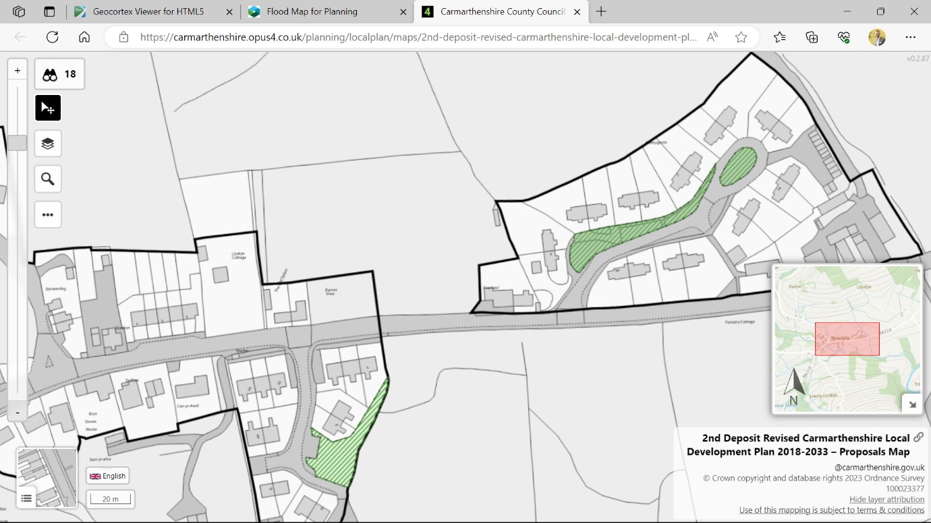

Appendix 2. Flood risk zone
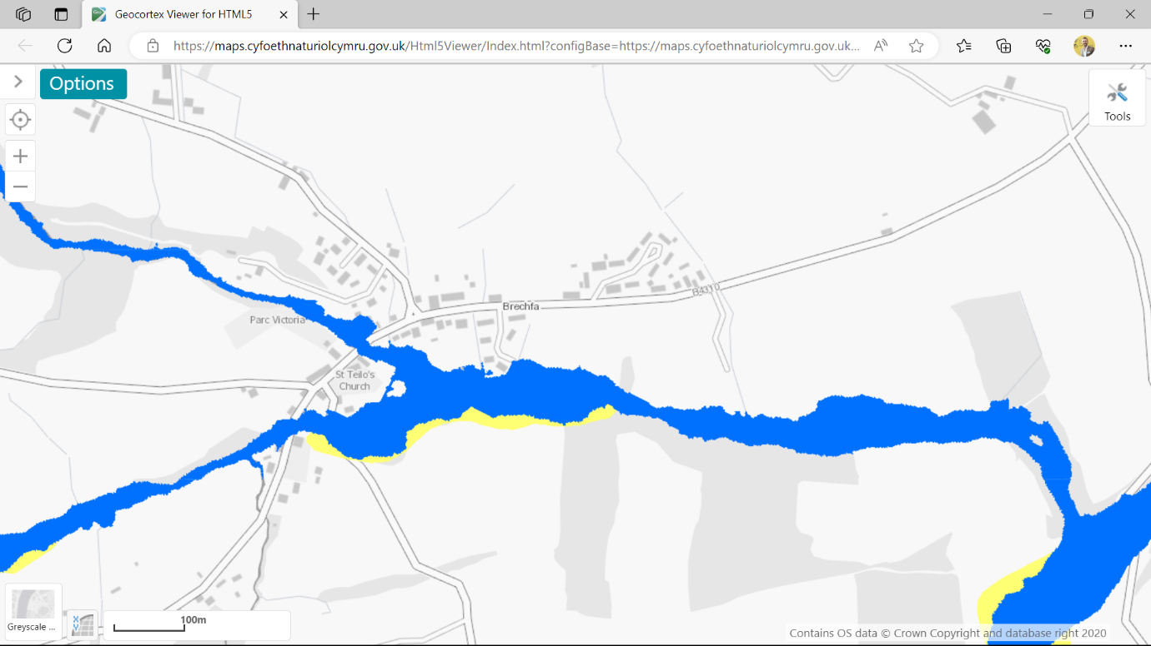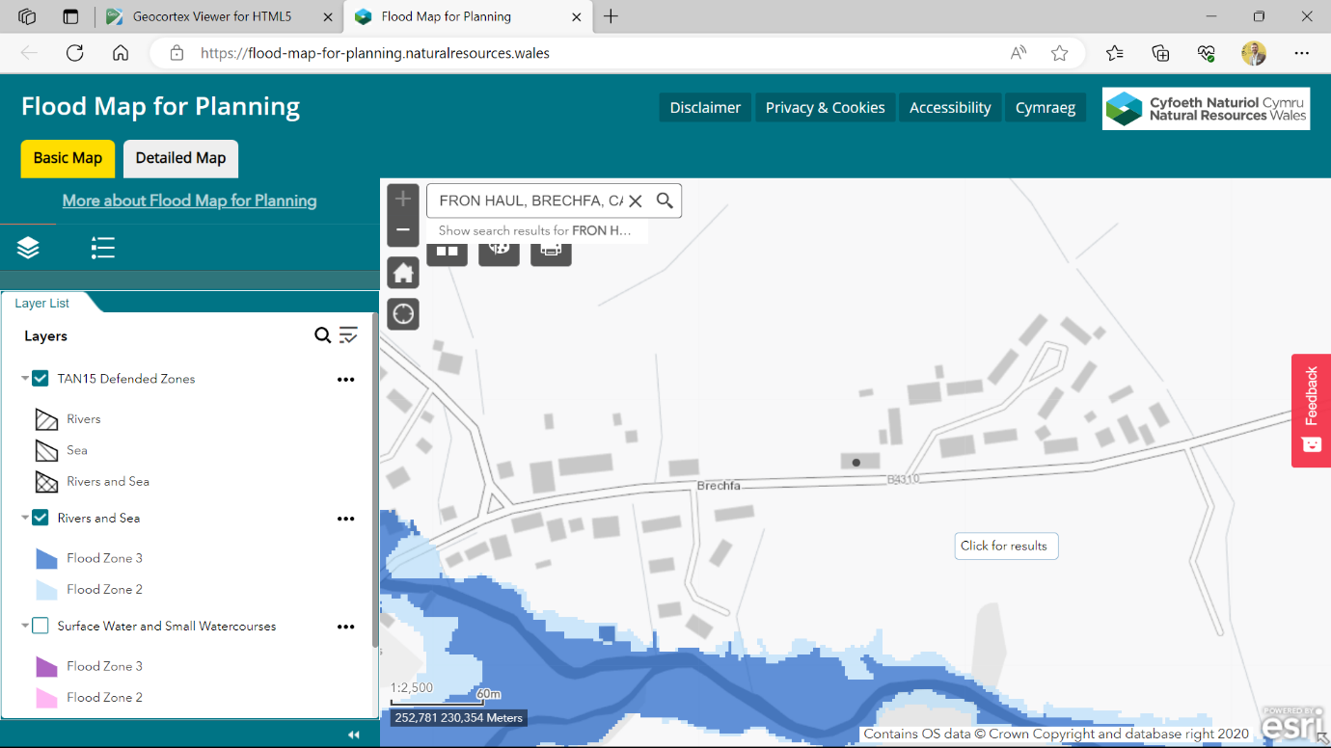
Appendix 3. rLDP constraints maps demonstrating site is not with or adjacent to any Scheduled monuments.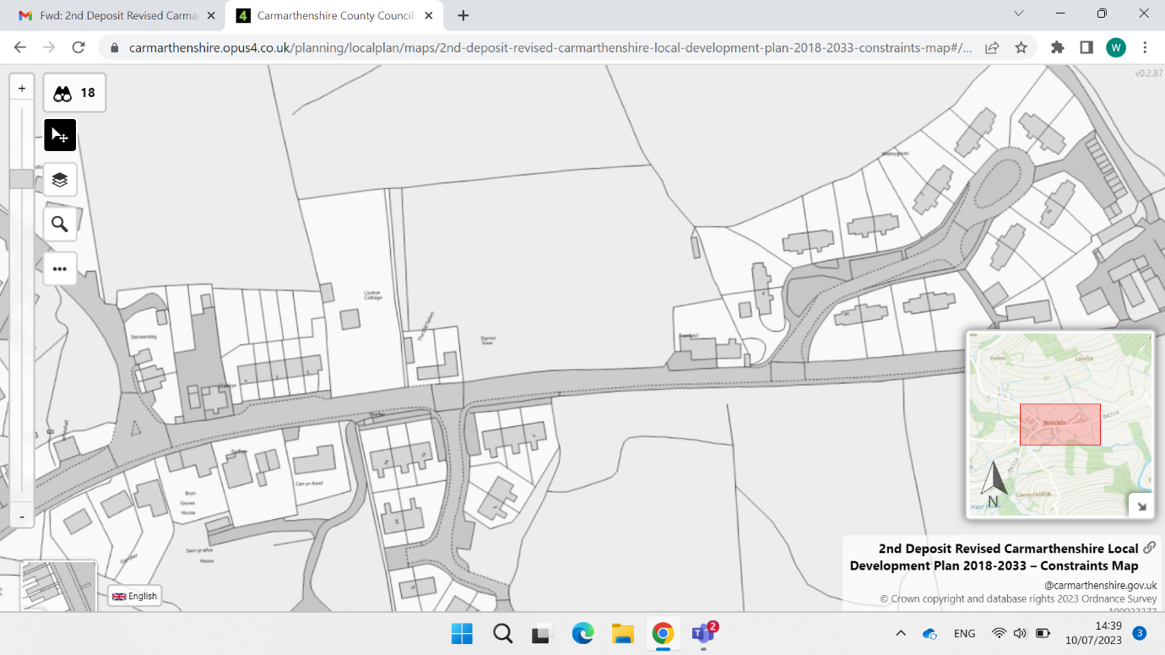

Appendix 4. Public transport access and active travel route.
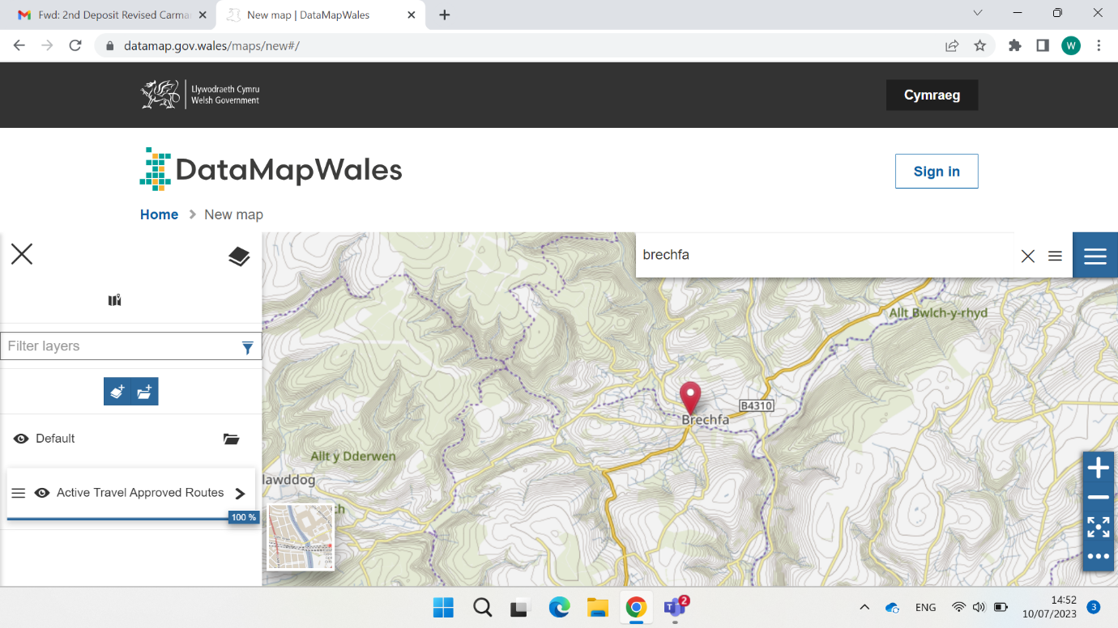

Appendix 5. Proximity to green space, leisure and recreational facilities.
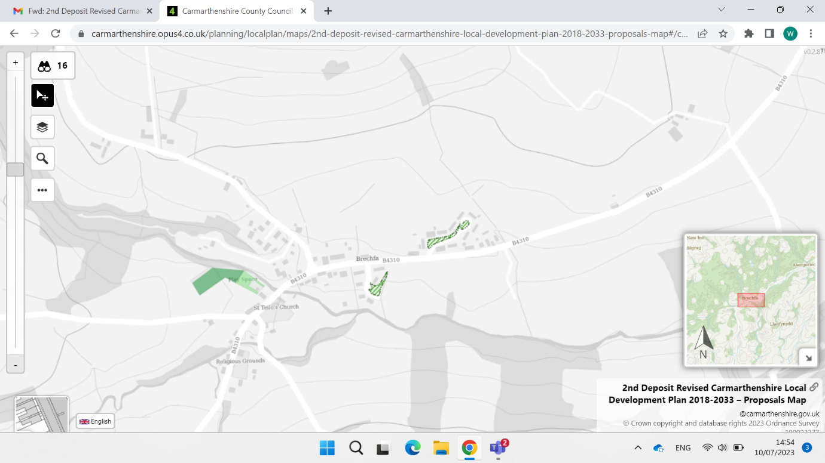

Appendix 6. School catchment areas.
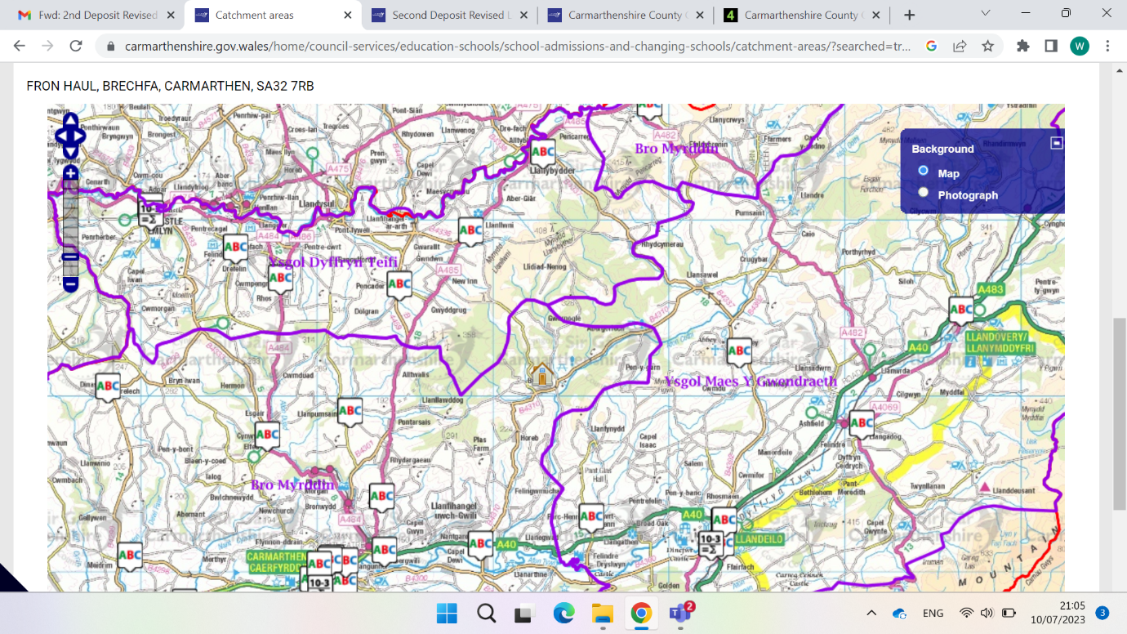

Appendix 7. rLDP proposals map showing site outside any mineral working and associated buffer zones.
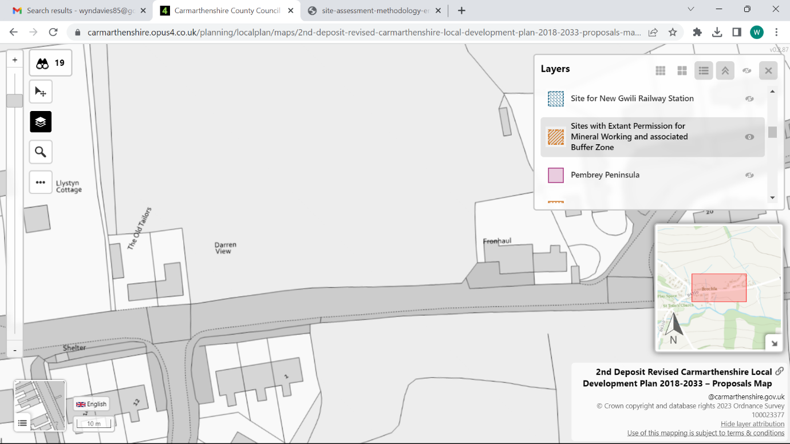

Appendix 8. rLDP constraints map showing mineral safeguarding area.
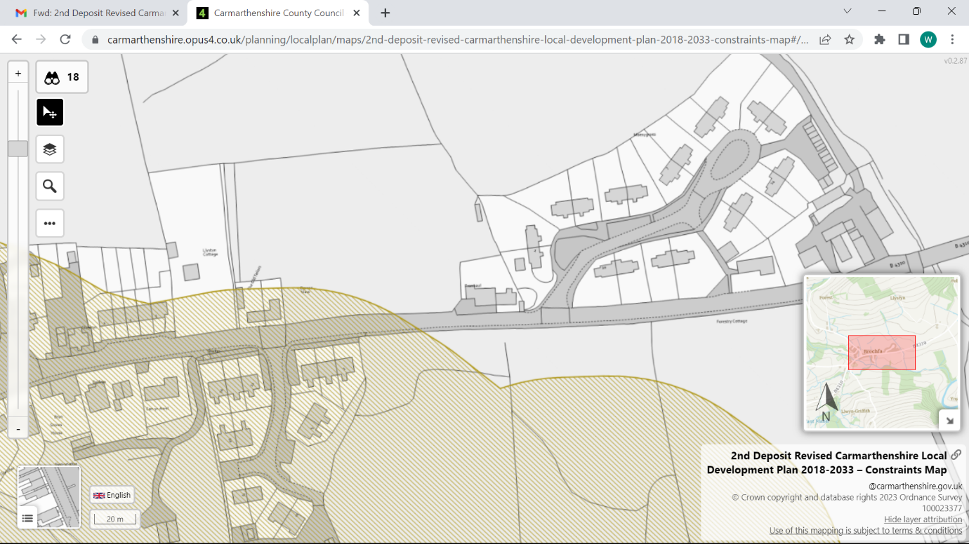

Appendix 9. rLDP Constraints map demonstrating site is not within or adjacent to AQMA.
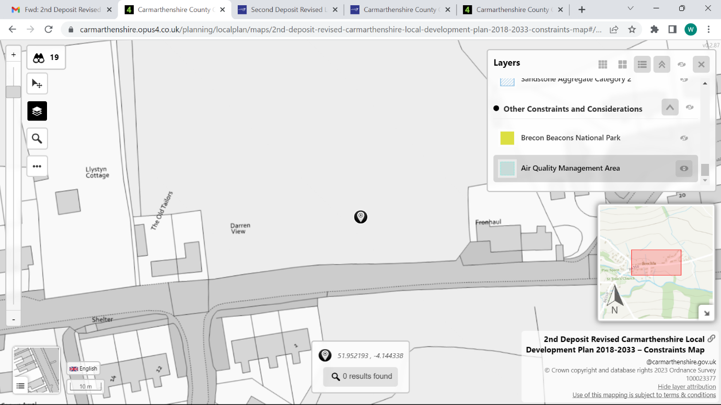

Appendix 10. Map of peat resources
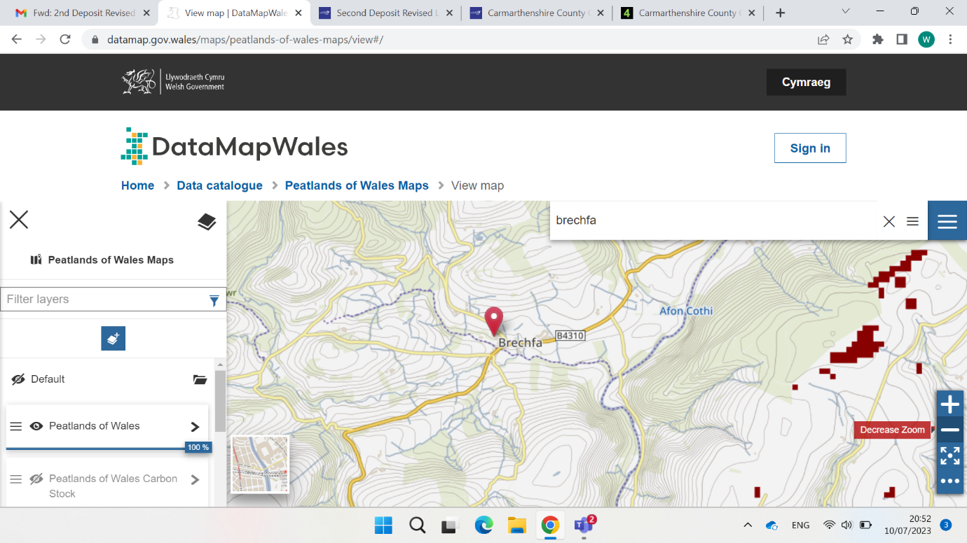

Appendix 11 Agricultural land grade – Site Grade 4.
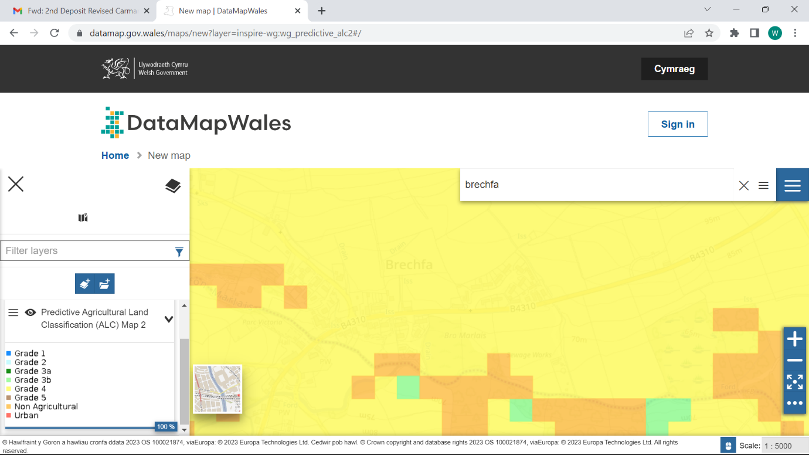

Appendix 12 Proximity to regionally important geological sites.
