**Proposed Revision of the Local Development Plan Carmarthenshire.**

**Proposed area - Capel Dewi.**

**Propsed site of revision - Land at Capel Dewi Lodge**

**For Mr Alexanda Alliston, Capel Dewi Lodge, Carmarthen, SA32 8AD**

This document contains a proposal to assess, revise and adjust the Local Development Plan for Carmarthenshire, Specifically within the village of Capel Dewi.

I have provided images of the Land at Capel Dewi Lodge before and after the removal of overgrowth/trees which I believe is the reason the land was never included in previous drafts of the development plan. Only now is it clear how suitable this piece of land is for development.

Please also find attacthed to scale images from google earth.

Given the settlement boundaries of Capel Dewi are in two main sections, East and West, my proposal will not affect this as the piece of land joining them is not owned by neighbours.

The Land at Capel Dewi Lodge appears to be the last piece of suitable, undeveloped land within the village. The proposed site would be for one property, with the remaining used as the garden.

Since the first subbisson of this proposal March 2020, there have been numereous new properties built withing Capel Dewi. Of the five Applications I believe only one can be considered as infill (SR/017/004) where as the other four appear to be extending the village, which has, and would inevitably result in the loss of valuable agricultual land. (SR/017/002) and (SR/017/005) also current build site (SuV16/h1).

I have spoken to my immediate neighbours, and as a new dwelling built on the Land at Capel Dewi Lodge will not affect them and can only be seen as a positive, they are all on board with and are excited about the prospect of a new dwelling and bring new neighbours into the ever evolving community.

Other properties within Capel Dewi are built on lesser ground.

The small brook that flows behind all the current properties has never burst its banks and each property it flows past has its own defence and/or flood protection in place.

Original access was uncovered when I purchsed Capel Dewi Lodge in 2013 allowing great visablity splays and line of sight, turning onto B4300 which enforces a strict 30mph speed limit thorughout the village, often patrolled by mobile speed cameras and soon to be lowered to 20mph.

Before the removal of severe overgrowth, the Land at Capel Dewi Lodge could have be mistaken as waste/woodland. However since being cleared it has presented an idilic location for a property with beautiful surroundings, in an historic village, with the opportunity to build the community.

I welcome and highly recommend a site visit.

Any fees for land registary and/or planning application with building regulations will be paid immediately when due.

Thank you for your time please consider my proposal look forward to hearing fromk you. I am open to ideas.

Land at Capel Dewi Lodge (highlighted in blue)

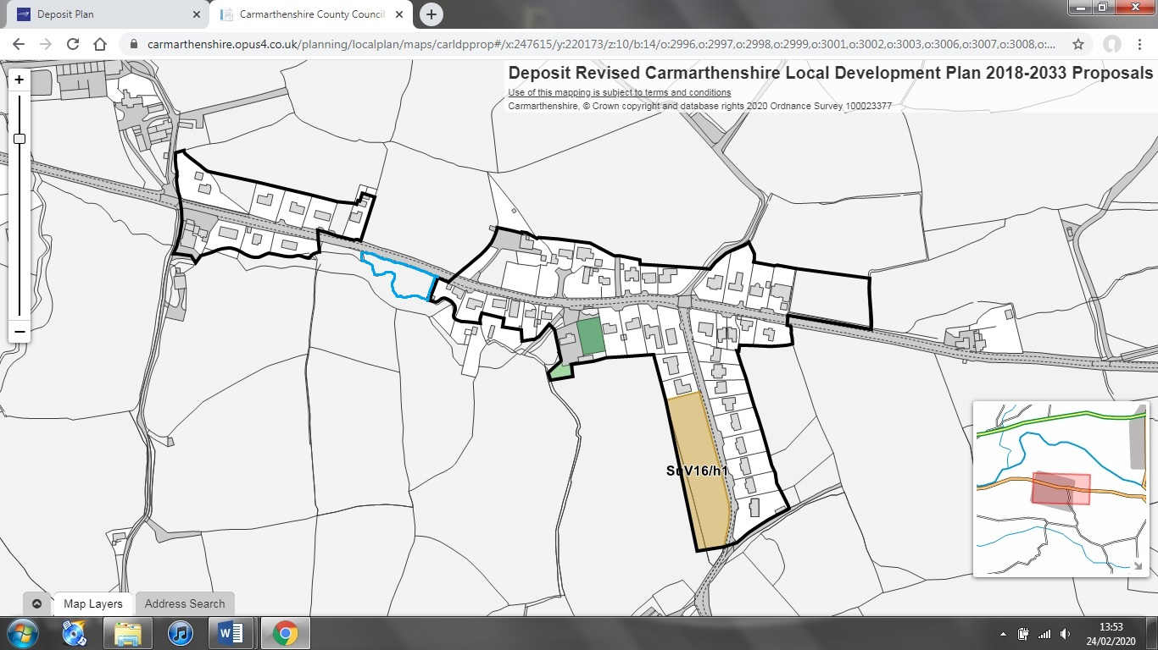

Proposed boundary evaluation application (highlighted in red)

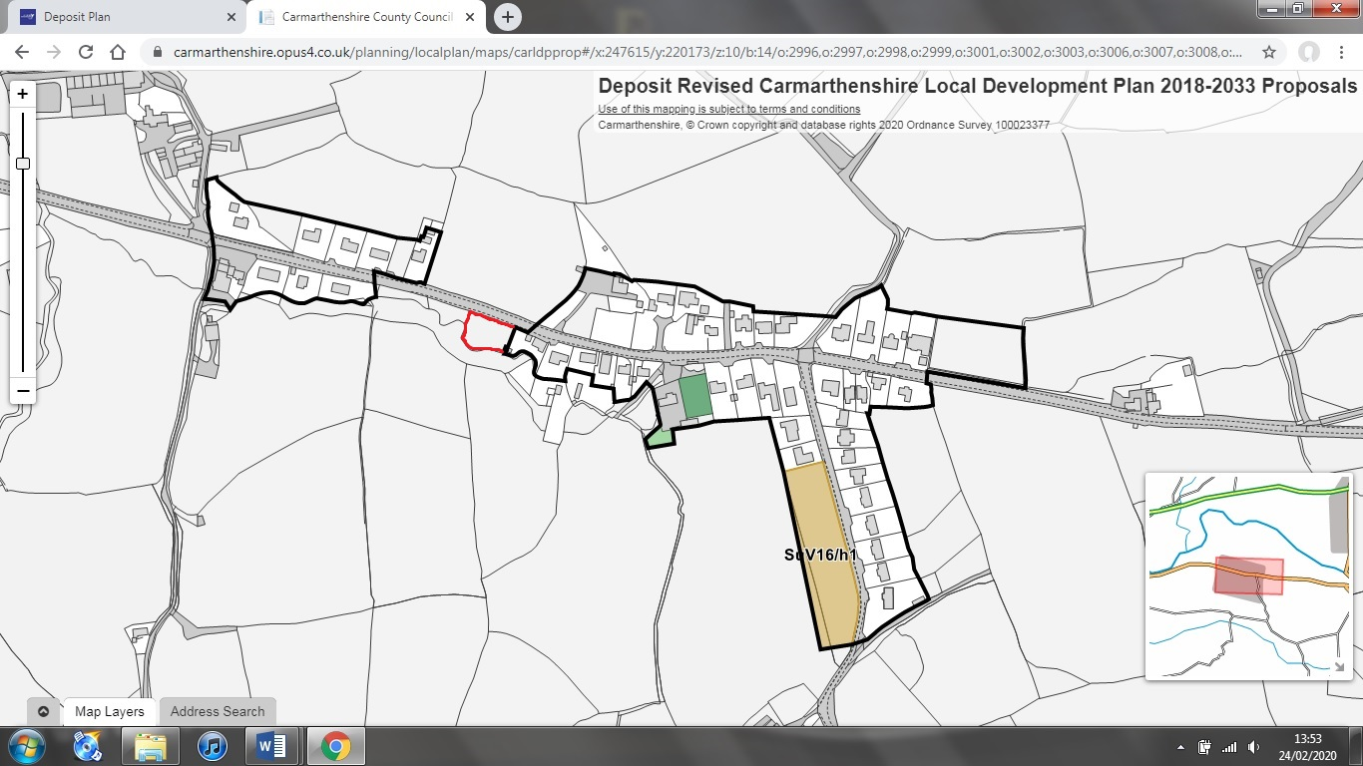

Current Planning Applications for the village of Capel Dewi.

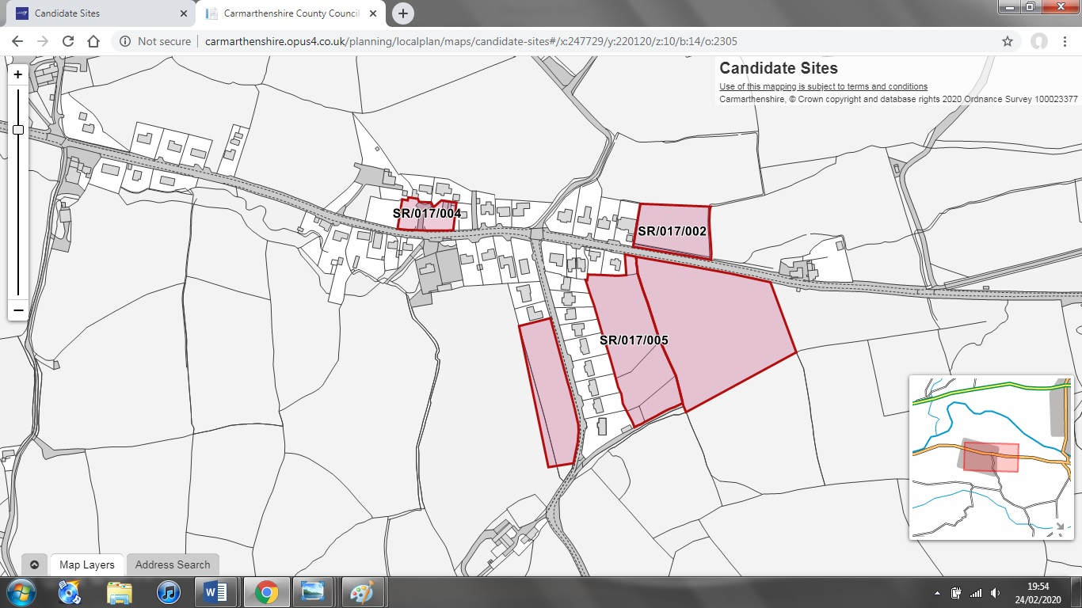

Proposed Planning Application (highlighted in red)

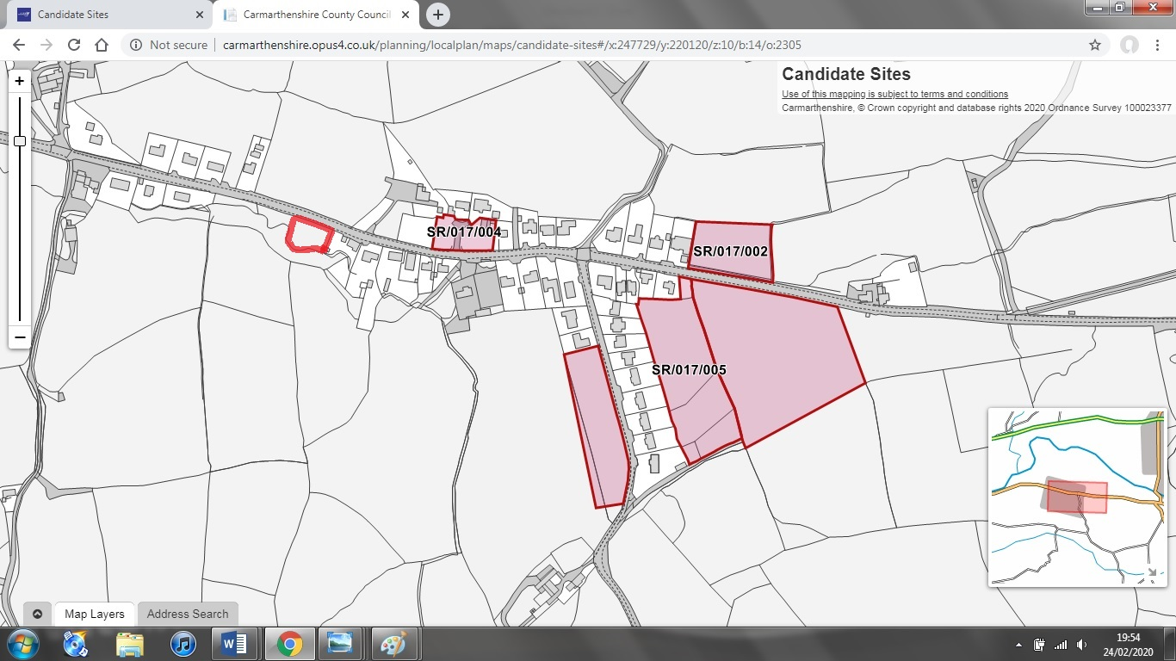

Scale images of Land at Capel Dewi Lodge via Google Earth approximately 80metres with access for the potential one property.

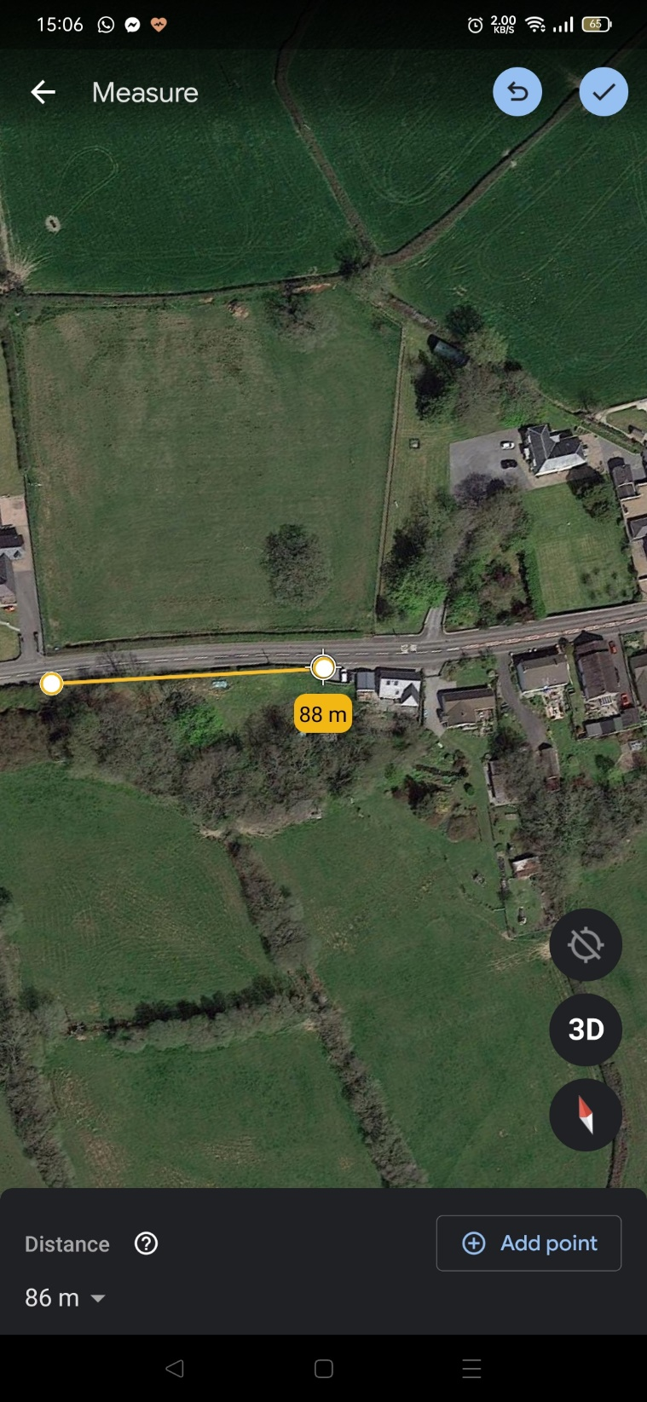

Scale images of land at Capel Dewi Lodge via Google Earth 28 metres

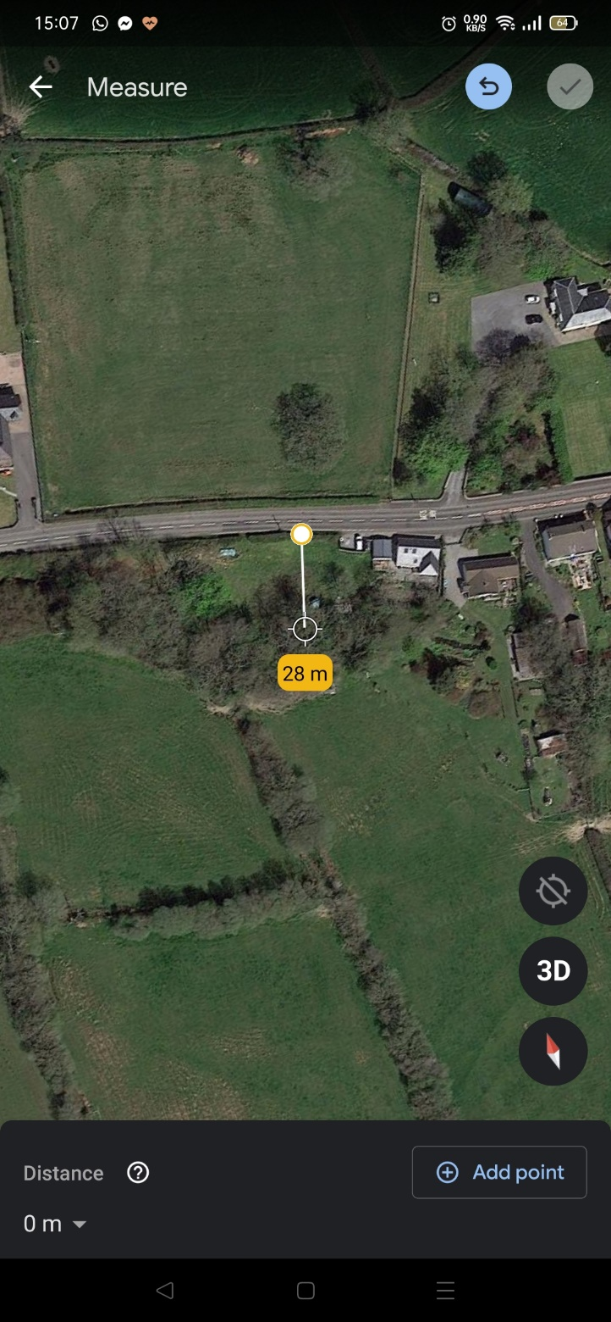

Hedgerow of proposed site access before removal of overgrowth 2013 (B4300)

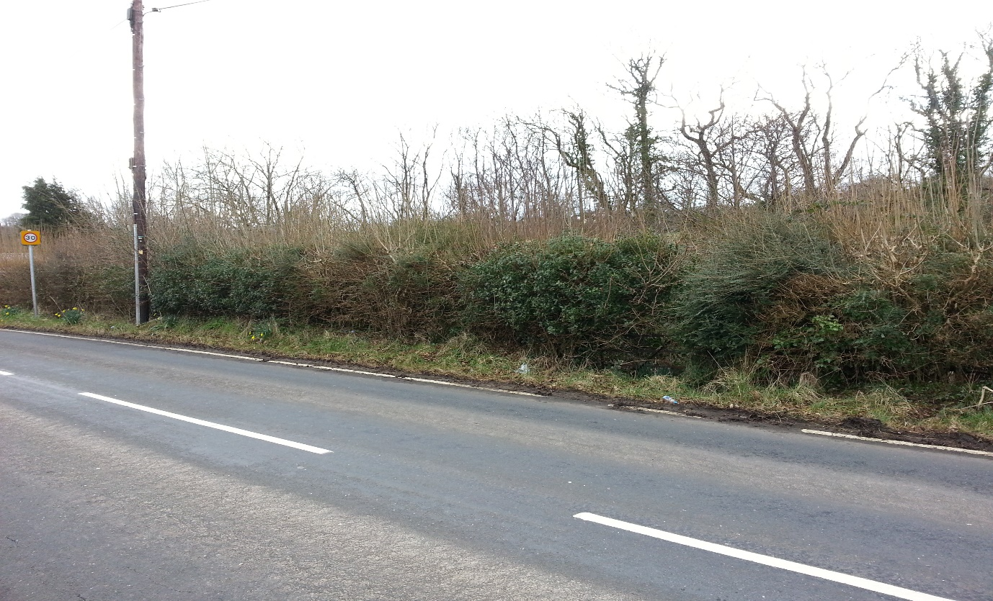

Hedgerow of proposed site after removal of overgrowth 2013 revealing access (B4300) showing access

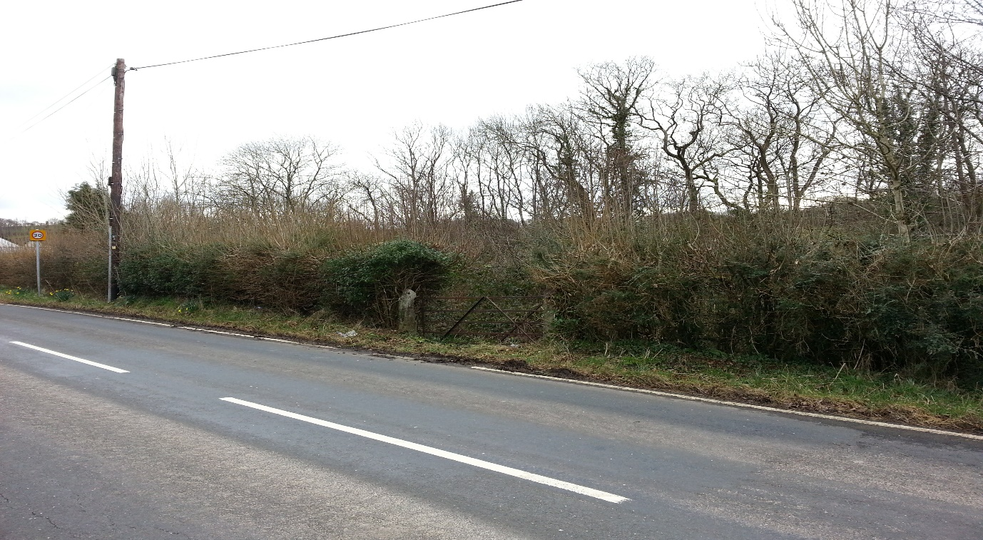

Image from google earth of the most recent developed plots in Capel Dewi (SuV16/h1) 5 properties over 90metres of land.

