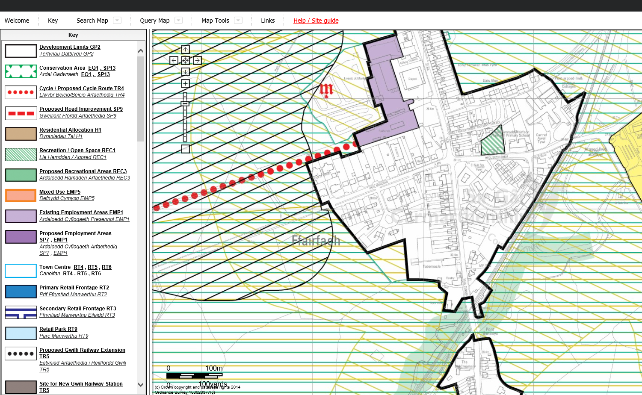

The black line shows the current boundary line of development limits. The drawn line in red shows the piece of land that we would like to be taken out of development limits.